Factor Analysis

Notes
Output Created |  | 28-JUN-2021 14:05:26
Comments
Input | Active Dataset | DataSet55
Input | Filter | <none>
Input | Weight | <none>
Input | Split File | <none>
Input | N of Rows in Working Data File | 259
Missing Value Handling | Definition of Missing | MISSING=EXCLUDE: User-defined missing values are treated as missing.
Missing Value Handling | Cases Used | LISTWISE: Statistics are based on cases with no missing values for any variable used.
Syntax |  | FACTOR  /VARIABLES ZGrocery ZTransit ZResidential  /MISSING LISTWISE  /ANALYSIS ZGrocery ZTransit ZResidential  /PRINT UNIVARIATE INITIAL CORRELATION EXTRACTION ROTATION  /FORMAT SORT  /PLOT EIGEN  /CRITERIA FACTORS(3) ITERATE(25)  /EXTRACTION PC  /CRITERIA ITERATE(25)  /ROTATION VARIMAX  /METHOD=COVARIANCE.
Resources | Processor Time | 00:00:00.28
Resources | Elapsed Time | 00:00:00.26
Resources | Maximum Memory Required | 1984 (1.938K) bytes

[DataSet55]

Descriptive Statistics
 | Mean | Std. Deviation | Analysis N
ZGrocery | 1.73127070 | .999999274 | 86
ZTransit | 2.32164058 | .999999495 | 86
ZResidential | 2.02688047 | 1.000000620 | 86

Correlation Matrix
 |  | ZGrocery | ZTransit | ZResidential
Correlation | ZGrocery | 1.000 | .556 | -.359
Correlation | ZTransit | .556 | 1.000 | -.912
Correlation | ZResidential | -.359 | -.912 | 1.000

Communalities
 | Raw |  | Rescaled
 | Initial | Extraction | Initial | Extraction
ZGrocery | 1.000 | 1.000 | 1.000 | 1.000
ZTransit | 1.000 | 1.000 | 1.000 | 1.000
ZResidential | 1.000 | 1.000 | 1.000 | 1.000

Extraction Method: Principal Component Analysis.

Total Variance Explained
 | Component | Initial Eigenvaluesª |  |  | Extraction Sums of Squared Loadings
 | Component | Total | % of Variance | Cumulative % | Total | % of Variance
Raw | 1 | 2.250 | 74.992 | 74.992 | 2.250 | 74.992
Raw | 2 | .690 | 22.996 | 97.988 | .690 | 22.996
Raw | 3 | .060 | 2.012 | 100.000 | .060 | 2.012
Rescaled | 1 | 2.250 | 74.992 | 74.992 | 2.250 | 74.992
Rescaled | 2 | .690 | 22.996 | 97.988 | .690 | 22.996
Rescaled | 3 | .060 | 2.012 | 100.000 | .060 | 2.012

Total Variance Explained
 | Component | Extraction Sums of Squared Loadingsª | Rotation Sums of Squared Loadings
 | Component | Cumulative % | Total | % of Variance | Cumulative %
Raw | 1 | 74.992 | 1.817 | 60.572 | 60.572
Raw | 2 | 97.988 | 1.102 | 36.727 | 97.298
Raw | 3 | 100.000 | .081 | 2.702 | 100.000
Rescaled | 1 | 74.992 | 1.817 | 60.572 | 60.572
Rescaled | 2 | 97.988 | 1.102 | 36.727 | 97.298
Rescaled | 3 | 100.000 | .081 | 2.702 | 100.000

Extraction Method: Principal Component Analysis.
a. When analyzing a covariance matrix, the initial eigenvalues are the same across the raw and rescaled solution.

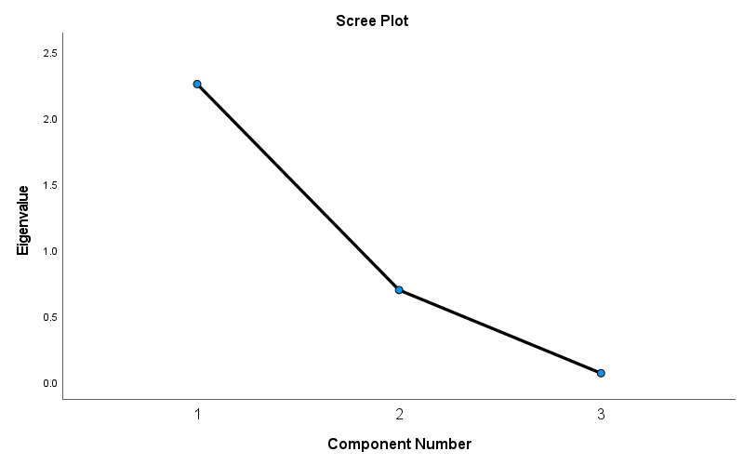

Component Matrixª
 | Raw |  |  | Rescaled
 | Component |  |  | Component
 | 1 | 2 | 3 | 1 | 2 | 3
ZTransit | .972 | -.152 | .182 | .972 | -.152 | .182
ZResidential | -.908 | .387 | .159 | -.908 | .387 | .159
ZGrocery | .693 | .719 | -.047 | .693 | .719 | -.047

Extraction Method: Principal Component Analysis.ª
a. 3 components extracted.

Rotated Component Matrixª
 | Raw |  |  | Rescaled
 | Component |  |  | Component
 | 1 | 2 | 3 | 1 | 2 | 3
ZResidential | -.985 | -.150 | .081 | -.985 | -.150 | .081
ZTransit | .894 | .359 | .270 | .894 | .359 | .270
ZGrocery | .219 | .975 | .040 | .219 | .975 | .040

Extraction Method: Principal Component Analysis.
Rotation Method: Varimax with Kaiser Normalization.ª
a. Rotation converged in 4 iterations.

Component Transformation Matrix
Component | 1 | 2 | 3
1 | .851 | .516 | .096
2 | -.520 | .853 | .028
3 | -.068 | -.074 | .995

Extraction Method: Principal Component Analysis.
Rotation Method: Varimax with Kaiser Normalization.

